Disability and loneliness

14th February 2017 11.00 – 13.00
The Vassall Centre

Disabled people have always been at risk of becoming isolated; negative attitudes to disability, public ignorance about mental health and learning difficulties, the barriers in the physical environment and low income have all played their role in making it difficult for them to get out and about and make friends. In recent years cuts to benefits and services have made the situation worse for many disabled people.
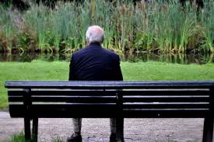
Being at home dependent on relatives for social contact and struggling to make friends puts strain on families and can create further issues.

SGDEN’s next Conference will look at the issue of Isolation and Loneliness and how it affects disabled people. The Conference will cover:

- What is the extent of the problem?
- How does it affect disabled people and their carers?
- Some examples of ways to break down isolation

The conference will open for registration and refreshments at 10.30am, and will be followed by a light lunch and SGDEN’s Annual General Meeting, to finish at 2pm.

To book your place please follow this link or go to the SGDEN website www.sgden.org.uk

